Chapter 12, Problem 65.

A balanced three-phase circuit is shown in Fig. 12.70. Use PSpice to find the line currents I_{aA}, I_{bB}, and I_{cC}.

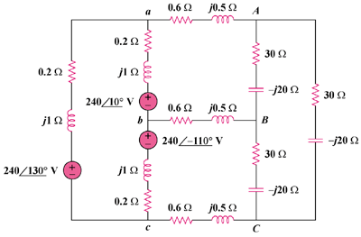
–
+

+

Figure 12.70
For Prob. 12.65.

